User Guide

The application is built for the staff of a faculty, helping them manage the candidates (future students). The results can be seen both inside the app or in the files.

The application was built in IntelliJ IDEA 13.

For starting the app, the user must open the CollegeAdmission.jar file located in the CollegeAdmission/out/artifacts by double clicking it.

When the application is started, the user has the choice of using it as a Candidate or Faculty Staff.

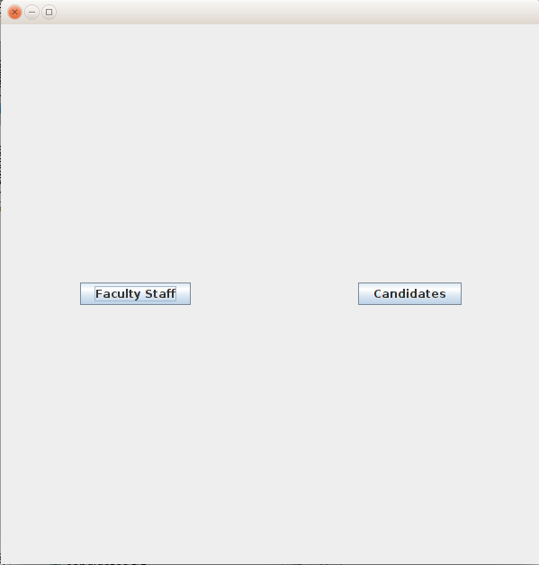

You can close the application at any time using the X button in the upper left corner.
If Faculty Staff button is pressed, the user is taken to the following screen.

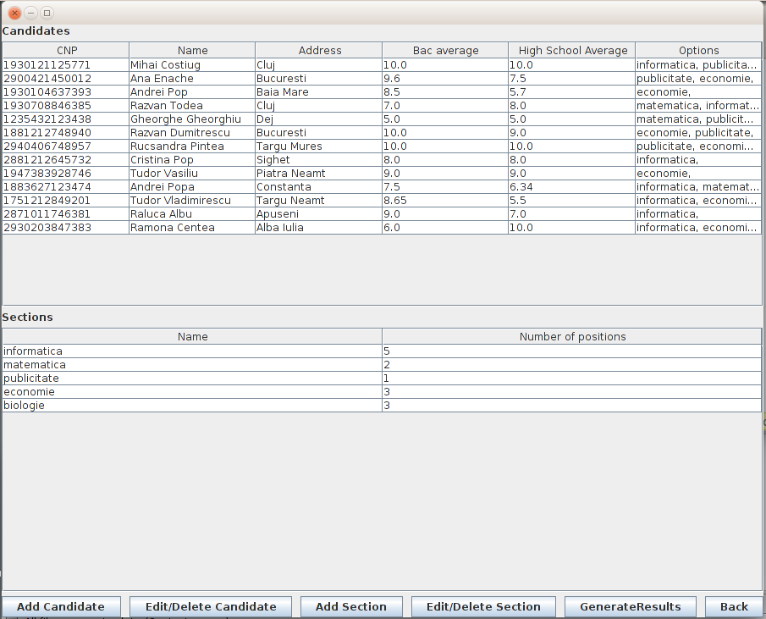

Here, the user can see all the candidates and all the sections, with their specific details. Also, from here he can Add/Edit/Delete Candidates and sections, as well as Generate the Admission Results. In order to edit or delete a candidate or a section, the user must first select it from the specific table, then press the specific button.

Here is the Edit/Delete View for a candidate.

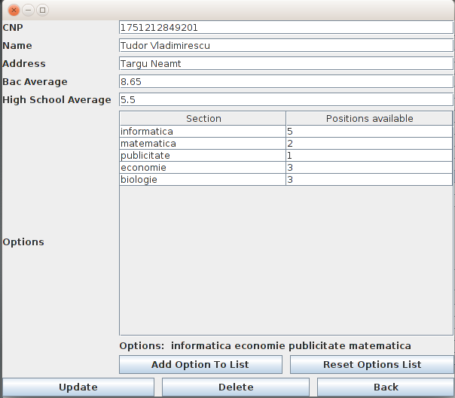

For selecting the options, the user must choose one section then press the “Add Option To List” button. The option will be then displayed above the button. A candidate can have any number of options, as long as they do not repeat.

The same technique applies to the section editor.

However, if you access this application as a candidate, this is the screen you'll be seeing.

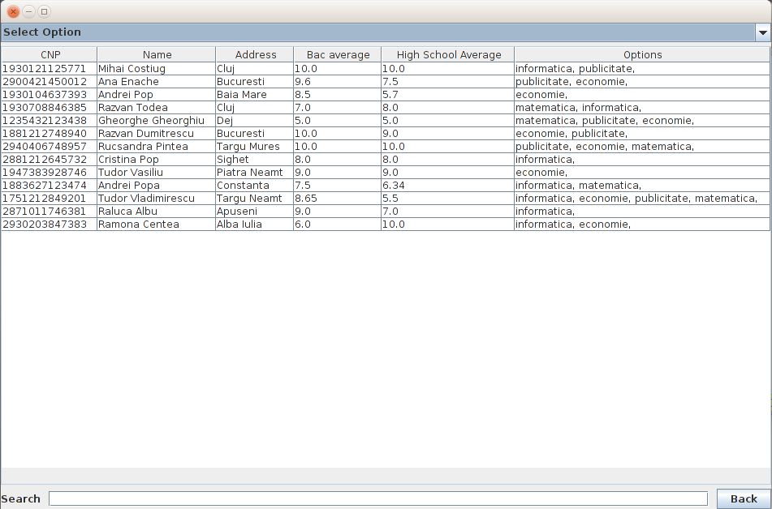
If “Select option” is selected, all candidates are displayed, with all of their info.
The user can select “See admitted candidates” or “See failed candidates” only after results have been generated, having the ability to search by tying in the search bar.

For closing the app, press X in the Home Form, Faculty Form or Candidates Form.

